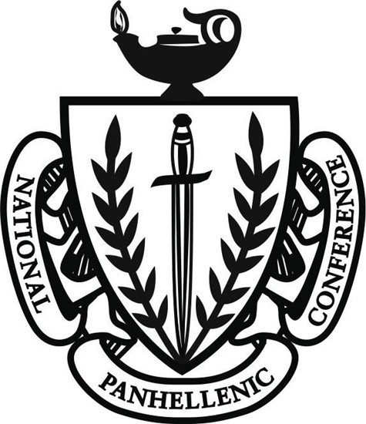
UNIVERSITY OF MINNESOTA - TWIN CITIES
COLLEGE PANHELLENIC ASSOCIATION
RECRUITMENT CODE OF ETHICS
We, the members of women’s sororities at the University of Minnesota - Twin Cities, agree to promote honesty, respect, sisterhood and cooperation within the College Panhellenic and our respective chapters and in our daily lives. This code of ethics is designed to inspire our members, reinforce exemplary conduct and values-based leadership, and perpetuate lifelong membership to enrich the sorority and Panhellenic experience.
We, as Panhellenic women of University of Minnesota - Twin Cities agree on and commit to:
- Uphold and demonstrate the Panhellenic spirit in thought, word and action through our chapters as well as individual members.
- Demonstrate ethical behavior and conduct ourselves in a manner consistent with the mission and values of the College Panhellenic, each inter/national organization and our university.
- Respectfully adhere to the Unanimous Agreements and all policies established by the National Panhellenic Conference.
- Avoid disparaging remarks about any sorority or collegiate woman and refrain from discussing Panhellenic matters with nonmembers, in accordance with the dignity and good manners of sorority women.
- Recognize friendly relations with all collegiate women, both sorority members and nonmembers, realizing the importance of creating and building friendships.
- Plan recruitment events that provide opportunities for the greatest possible number of women to become sorority members while protecting the rights and privileges of individuals and the chapters.
- Provide a safe, positive and enriching recruitment experience; understanding that membership is a social experience arrived at by mutual selection.
- Strive to be truthful, honorable, open and friendly to all potential new members during all recruitment events.
- Be respectful of the rights of every potential new member to make her own choices, including the right not to join the women’s sorority community.
- Refrain from limiting a potential new member’s chances of becoming a member of the Panhellenic community by encouraging her to make a single intentional preference or to limit her choices.
We, as Panhellenic women of the University of Minnesota - Twin Cities also agree on and commit to:
- Respectfully adhere to the bylaws and recruitment rules of the University of Minnesota Panhellenic Council.
- Abide by all local and federal laws and NPC inter/national member organization bylaws.
- Hold one another accountable to these standards, remembering at all times that we represent not only our individual chapters but also the Panhellenic community as a whole.
- Recognize diversity within chapter membership as a strength and goal for all member chapters and commit to fostering an inclusive and diverse environment in both our Panhellenic and campus communities.
As Panhellenic women of the University of Minnesota - Twin Cities these are the tenets by which we strive to live.

Date adopted: 5/10/2015

